DEC RECOMMENDED PRACTICES – OVERVIEW AND RESOURCES

What are the Recommended Practices? https://www.dec-sped.org/dec-recommended-practices
The DEC Recommended Practices were developed to provide guidance to practitioners and families about the most effective ways to improve the learning outcomes and promote the development of young children, birth through age 5, who have or are at-risk for developmental delays or disabilities. The purpose is to help bridge the gap between research and practice by highlighting those practices that have been shown to result in better outcomes for young children with disabilities, their families, and the personnel who serve them. While the benefits to children with or at risk for disabilities are clear, these evidence-based practices also support the other young children in any setting. The topics around which Recommended Practices have been gathered are:

Leadership | Assessment | Environment | Family
Instruction | Interaction | Teaming and Collaboration | Transition

Resources at this website include:
- Recommended Practices in English and Spanish
- Glossary of terms
- Recommended Practices with embedded examples (illustrations of what each practice might look like in different home and early childhood settings)
- Recommended Practices with interactive glossary (key terms are highlighted and linked to definitions)

Practice Improvement Tools: Using the DEC Recommended Practices https://ectacenter.org/decrp/
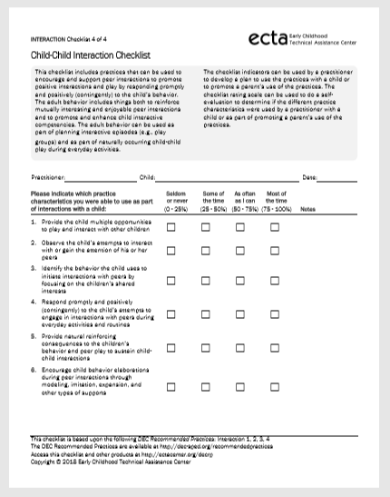
The Practice Improvement Tools were developed to support implementation of the evidence-based practices. They are based on the DEC Recommended Practices. Tools and resources are organized around the eight topics of the DEC Recommended Practices and are designed to guide educators, practitioners, administrators, and families in supporting young children who have, or are at-risk for, developmental delays or disabilities across a variety of early childhood settings. They include performance checklists, practice guides, and professional development guidance materials.

Performance Checklists (https://ectacenter.org/decrp/type-checklists.asp) can be used to learn about recommended practices, improve skills, plan interventions, and self-evaluate the use evidence-based practices. For example, under the Interaction topic, the Child-Child Interaction Checklist provided to individuals who are watching a video that shows children with and without disabilities in an inclusive classroom. Using the checklist, observers can identify the Recommended Practices that they see. They might then have a discussion of the Recommended Practices they don’t see, and how those practices might be incorporated. All Performance Checklists are available in English and Spanish.

Practice Guides for Practitioners (https://ectacenter.org/
decrp/type-pgpractitioner.asp) provide information and illustrations of Recommended Practices in each of the topical areas. For example, one of the Practice Guides under the topic of environment is Adapting Children’s Learning Opportunities, which may be downloaded as a PDF or as a Mobile PDF Each Practice Guide includes information about and examples of the practice, a video that shows the practice, and a vignette illustrates how the practice might be used in a real world setting. The final section of the Practice Guide supports progress monitoring by sharing examples of what you should see if the practice is working. Family Practice Guides are also available, in English and Spanish. Each Family Practice Guide includes the same features as the Practice Guides for Practitioners (examples, video, illustrations, etc.), as you see on the left.
Recommended Practice Modules (https://rpm.fpg.unc.edu/)

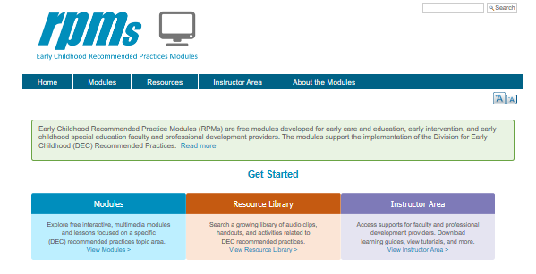
The Recommended Practice Modules are free modules developed for early care and education, early intervention, and early childhood special education faculty and professional development providers. The modules support the implement-ation of the DEC Recommended Practices. There is a free, inter-active, multimedia module for seven of the eight areas of Recommended Practice.

The website is organized in three sections.
Modules https://rpm.fpg.unc.edu/modules-list
Each module includes learning objectives, information, examples and activities, voices from the field, and opportunities for practice. The content of each module is organized using the plan-do-study-act framework to build both knowledge acquisition and knowledge application.

Module 1: Interaction | Module 2: Transition | Module 3:  Environment

Module 4: Teaming and Collaboration | Module 5:  Family | Module 6: Instruction | Module 7: Transition

Resource Library https://rpm.fpg.unc.edu/resource-search-facets
This compilation of resources includes audio and video clips, activities, handouts, and lists of references and resources cited in the seven modules. You may use the keyword search by typing a term into the search box, or use the guided search feature, which allows you to narrow your search by topic area, type of resource, or step in the Learning and Improvement Framework.

Instructor Area https://rpm.fpg.unc.edu/groups/instructor-area
This section of the website has guides to assist faculty/instructors, a discussion area to exchange ideas, and tutorials to orient you. Each Learning Guide provides specific examples of how to embed all or individual parts of a module into existing coursework and field experiences. Objectives are available for each activity and extensive options for observation, practice, and application are spelled out. A Practice Profile even offers options that might form the basis for a rubric for assignments that come from each module.

