The 2014 DEC Recommended Practices underscore the importance of using Universal Design for Learning (UDL) approaches to “create accessible environments for children” (page 8). In addition to using these principles to support each child, UDL concepts can also be used to support effective collaboration with family members. Here’s an example of an activity/assignment that can familiarize students with how UDL approaches can enhance the effectiveness of meetings.

- Access the Families are Full Team Members Checklist at http://www.ectacenter.org/~pdfs/decrp/TC-1_Families_Are_Full_Team_Members.pdf (sample below).

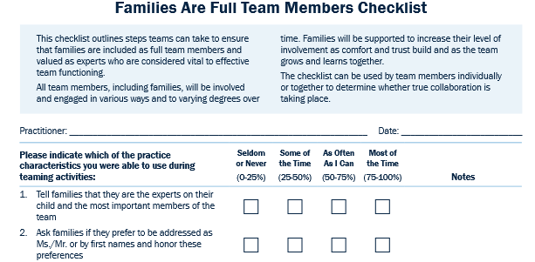

- Ask students to review the checklist of evidence-based and recommended practices for examples of how they reflect UDL concepts. For example, “share information that is jargon-free, clear and simply stated so that ALL members can understand and participate in conversations and decisions” reminds us implicitly of the UDL concept of multiple means of expression.
- Next, ask students to explicitly identify strategies they could use to support a family’s comfort and participation in a meeting. Think about what strategies might be used before a meeting, during a meeting, and after a meeting. For example, how could you expand on the multiple means of expression concept by sharing information by phone, email, or text (based on family preference) before and after the meeting?
- Compile all responses to provide students with multiple examples of effective strategies for supporting family engagement.

Division for Early Childhood. (2014). DEC recommended practices in early intervention/early childhood special education 2014. Retrieved from http://www.dec-sped.org/recommendedpractices

