Ideas and Strategies for Incorporating Foundations
in Infants, Toddlers, and Twos

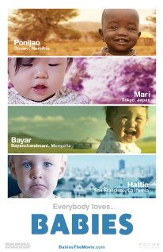
The 2010 film Babies offers a plethora of opportunities to support students in understanding the cultural and developmental components of supporting very young children. It shows family members supporting a baby in each of four locations – Mongolia, Namibia, Hong Kong and San Francisco.

Babies (Studio Canal+, 2010), written by Thomas Balmès and Alain Chabat, and directed by Thomas Balmès, is available from Netflix or may be streamed directly from Amazon Instant Video for $2.99. To learn more about the film, instructors may find it useful to visit the Babies website (http://www.imdb.com/title/tt1020938/), where you can watch a trailer.

First, show students the first few minutes of the film – enough time for them to meet Mari, Hattie, Ponijao, and Bayarjargal. Stop the film and check in with students to hear about their initial impressions of each baby and his/her caregivers. In a face-to-face course, consider dividing the students into four groups and asking each group to focus on one of the babies.

Once students are familiar with the context, ask them to watch the remainder of the film through the lens of Foundations. Challenge them to identify a developmental indicator they can observe in each domain for each baby. Discuss what developmental characteristics they saw for each baby across all domains.

Follow this segment of the activity with a discussion. Here are some possible questions:
1. How do the environments of each baby differ from each other? What do they have in common?

2. What were the most striking similarities among these children and their experiences?

3. What were the most striking differences among these children and their experiences?

4. To what extent do each of the families encourage independence? Interdependence? Dependence?

5. Did the film give you any new thoughts or observations about your own culture?

6. What questions do you still have about each baby?

7. What further information would you find useful?

Consider the following follow-up assignment.
Imagine this: Mari, Ponijao, or Bayarjargal’s family is about to relocate to a program in your community in the US. If you were working as a teacher in that program (or a consultant to that program), what would you do to ensure that each child and family benefits from thoughtful, culturally-responsive services and supports?

Foundations is the North Carolina resource “that describes children’s development and learning from birth to age five.” Please adjust the activities and assignments to incorporate the use of your state’s early learning guidelines/standards. Retrieved from http://ncchildcare.nc.gov/pdf_forms/NC_foundations.pdf (page v).

