data-based decision making. A common assignment in an infant-toddler course requires students to observe a young child over time and document what is observed. Consider incorporating an intentional emphasis on making the connections between observation/documentation and decision making by requiring students to thoughtfully use the data they collect to determine whether adjustments should be made and what those adjustments might be.

Resources
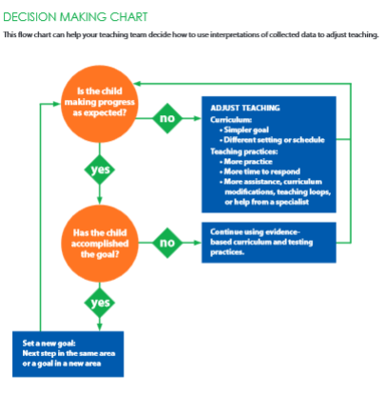
Here are several resources on how to connect data collected from observation/documentation and decision making.

Tips for Teachers Using Data to Inform Teaching
https://eclkc.ohs.acf.hhs.gov/hslc/tta-system/teaching/docs/using-data-teacher-tips.pdf

Decision Making Chart (at right) for using data to make decisions
https://eclkc.ohs.acf.hhs.gov/hslc/tta-system/teaching/docs/using-data-teacher-tools.pdf

Helpful Resources on Using Data to Inform Teaching (articles and websites)
https://eclkc.ohs.acf.hhs.gov/hslc/tta-system/teaching/docs/using-data-resources.pdf

Using Data to Inform Teaching (video from the National Center for Quality Teaching and Learning) https://eclkc.ohs.acf.hhs.gov/hslc/tta-system/teaching/practice/assessment/iss/inform-teaching.html?utm_medium=email&utm_campaign=NCQTL%20Disabilities%20Newsletter%20-%20March&utm_content=NCQTL%20Disabilities%20Newsletter%20-%20March+CID_b39c152c62db44d028b78bda8c40efb2&utm_source=CM%20Eblast&utm_term=Using%20Data%20to%20Inform%20Teaching
(NOTE: The video highlights preschool examples so instructors will need to support the translation to infants, toddlers, and twos).

Graphing Data
Consider incorporating an emphasis on graphing data obtained from observing in an infant/toddler setting over time. Here are examples of how that could happen.
- Create a simple table that lets students collect data and see the child's progress. For example, to track the number of challenging behaviors a child has from week to week: Designate each visit (Visit 1, Visit 2) across the top row, and the numbers from "5" to "1" (or "10" to "1") down the left column. If the student fills in the box next to the "1" in the Week 1 column, the child had one or fewer challenging behaviors. If the student fills in all five boxes, the child had five or more challenging behaviors. After several visits, the student will have a quick snapshot of the child's progress.
- A student could also make a table that creates its own line graph. For example, to track the number of conversational turns a child takes while talking to a peer: Draw a table with the dates for one week (or one visit) across the top row and the numbers from "5" to "1" (or other numbers) down each column. Each day (or visit), highlight or circle the number of the child's conversational turns. After several visits, the student will be able to draw a line to connect the circles and create a simple line graph.

From Head Start Disabilities Services Newsletter, March 2015/Issue No. 45.

