Ideas and Strategies for Incorporating Foundations
in Social-Emotional Development/Child Guidance

Use Foundations to build knowledge of the social emotional development of infants and toddlers

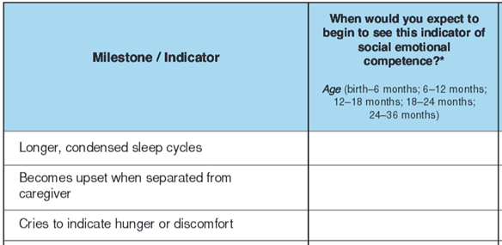
CSEFEL’s Handout 1.10 (Social Emotional Milestones Group Quiz http://csefel.vanderbilt.edu/
resources/inftodd/mod1/1.10.pdf) can easily be modified to create an activity for using Foundations to learn about the social-emotional development of infants and toddlers. Use your Windows Snipping Tool to create a version that looks like the one excerpted to the left. Ask students to review the Emotional Social Development section of Foundations, looking specifically at the developmental indicators for infants, younger toddlers, and older toddlers (birth – 36 months). Then pair students up to fill in the column on the right, identifying the age at which you might expect to begin to see each indicator of social emotional competence. Debrief the activity together to develop a shared understanding of the developmental continuum. (NOTE: CSEFEL handout 1.9 (Developmental Continuum from Birth – Age 3 ½: Social Emotional Indicators) provides a concise overview of development milestones http://csefel.vanderbilt.edu/resources/inftodd/mod1/1.9.pdf

Use Foundations to build knowledge of the social-emotional development of younger and older preschoolers
Develop your own chart like the sample below, drawing from the Emotional Social Development section of Foundations and looking specifically at the developmental indicators for younger and older preschoolers (36 – 60+ months). Then pair students up to fill in the middle column, identifying the age at which you might expect to begin to see each indicator of social emotional competence. Ask them to also consider factors that might delay the appearance of each indicator and to list those in the column on the right. Debrief the activity together to develop a shared understanding of the developmental continuum.

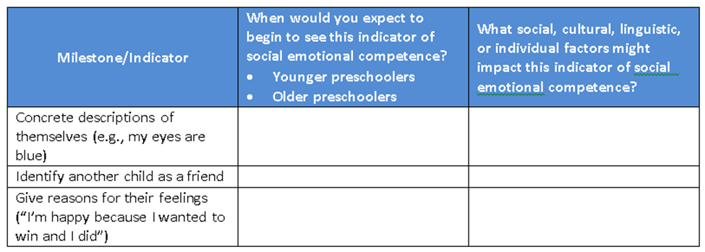

Foundations is the North Carolina resource “that describes children’s development and learning from birth to age five.” Please adjust the activities and assignments to incorporate the use of your state’s early learning guidelines/standards. http://ncchildcare.nc.gov/pdf_forms/NC_foundations.pdf (page v).

