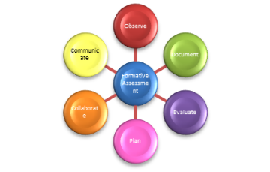
What Is Formative Assessment? Introduce and discuss the concept of formative assessment, underscoring how it relates to the development of young children. Then ask students to find their state’s definition of formative assessment online. For example, the North Carolina Division of Child Development and Early Education defines formative assessment as “systematic ongoing procedure to document, monitor and evaluate children’s progress, and plan appropriate learning experiences by:
- Observing, documenting and evaluating all children’s development, knowledge, skills, behaviors, strengths, needs and interests in all areas defined in North Carolina Foundations for Early Learning and Development;
- Providing opportunity for communication and collaboration with families, teachers, and service providers regarding children’s interests, development, and learning; and
- Providing data that teachers can use to systematically plan and evaluate learning experiences and teaching practices based on documentation of the learning and development of a diverse group of children.”

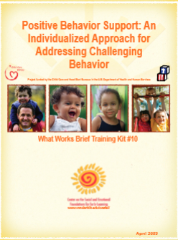
Ideas for Incorporating Components of Formative Assessment in this Course
What Works Brief Training Kit #10, Positive Behavior Support: An Individualized Approach for Addressing Challenging Behavior, provides all the material for a series of activities/assignments related to social emotional development and formative assessment at http://csefel.vanderbilt.edu/kits/wwbtk10.pdf Materials in the Training Kit include a vignette about Amy, a 4-year old with some significant problem behavior, as well as PowerPoint slides (with presenter notes) and handouts for using the vignette to consider gather information (conduct a functional assessment), develop a behavior support plan, and implement and evaluate the success of the plan.

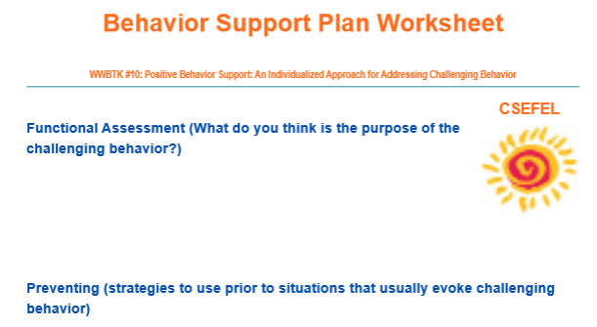

NC Curriculum and Assessment Review Committee Working Title, Definition and Criteria for Assessments http://ncchildcare.nc.gov/pdf_forms/definition_and_criteria_for_formative_assessments.pdf

