Ideas and Strategies for Incorporating Foundations
in Health, Safety and Nutrition

Use Foundations to build knowledge of the links between health and each domain of development

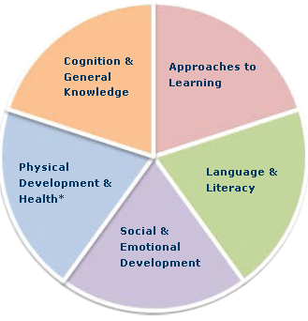
Too often students only see the connections between health and physical development. One way to help students learn about links between health and all domains of development is through an assignment called What’s the Link? This assignment makes use (for instructors) of a Head Start website (http://eclkc.ohs.acf.hhs.gov/hslc/tta-system/health/link-between/five-domains.html) that provides information about the links between five domains (approaches to learning, cognition and general knowledge, language and literacy, social and emotional development, and physical health and development). For each of these domains, the website provides a short statement about the link between children's health and that specific learning domain, research connections with science-informed evidence, and a printable table including examples of school readiness goals and health strategies.
Here’s how to set the assignment up.
- Ask students to provide evidence to respond to the following questions:
- What’s the link between health and approaches to learning?
- What’s the link between health and emotional-social development?
- What’s the link between health and physical development?
- What’s the link between health and language/communication?
- What’s the link between health and cognitive development?
- Require that students provide the following as part of their responses:
- A summary statement about the link(s) between health and each domain of development; and
- Evidence sources to document the links.
NOTE: Provide students with an example of what a summary statement or evidence sources might look like. Create examples of your own, of use examples from the Head Start website.

Foundations is the North Carolina resource “that describes children’s development and learning from birth to age five.” Please adjust the activities and assignments to incorporate the use of your state’s early learning guidelines/standards. http://ncchildcare.nc.gov/pdf_forms/NC_foundations.pdf (page v).

